**Introduction to Energy**

**Directions**:

1. After completing the stations, matching and readings, you will complete the following conclusions

**A. Station One-Part Three: Toys**

|  | Forms of Energy Observed |
| --- | --- |
| Toy Car | Mechanical energy was energy that made the car wind back and go super fast. |
| Balloon | With electromagnetic waves, electricity, and rubber it is elastic energy. |
| Yo-Yo | The yo yo when going up experiences potential energy and going back down experiences kinetic energy. |

**Conclusion**

Using the forms of energy you observed, what transformations occurred?

|  | Energy Transformation |
| --- | --- |
| Toy Car | When the car is pulled back the gears wind up inside and mechanical energy is at work there and when it is released the gears spin very fast to create a pulse to move the car in a direction. |
| Balloon | With electromagnetic waves, electricity, and rubber it is elastic energy and when the balloon blows up the electricity and elastic makes it very light and it starts to float. |
| Yo-Yo | The yo yo when coming off the ground and coming up uses potential but dropping to the bottom the string drops to, so it creates kinetic energy. |

**B. Station 3: Part One: Sunlight and Shade**

**Conclusion**

Answer the following using complete and detailed sentences. Use data to support your reasoning.

Explain how direct light affects the temperature of an object. What energy transformations occurred? Use data to support your reasoning.

| The Sunlight and shade was a very cool process. On one end you would have the thermometer heated up by the sunlight while the other thermometer was in the shade. The energy transformations that occurred were heat energy to power up the thermometer and kick the temperature high. |
| --- |

**Use** [**this link**](https://nces.ed.gov/nceskids/createagraph/default.aspx?ID=1abc3a1e611149a283aa865285ba8df7) **to create a graph of this data. Use a line graph.**

1. **Make sure to title the graph and your axes**
2. **Set up the Data Set as shown:**

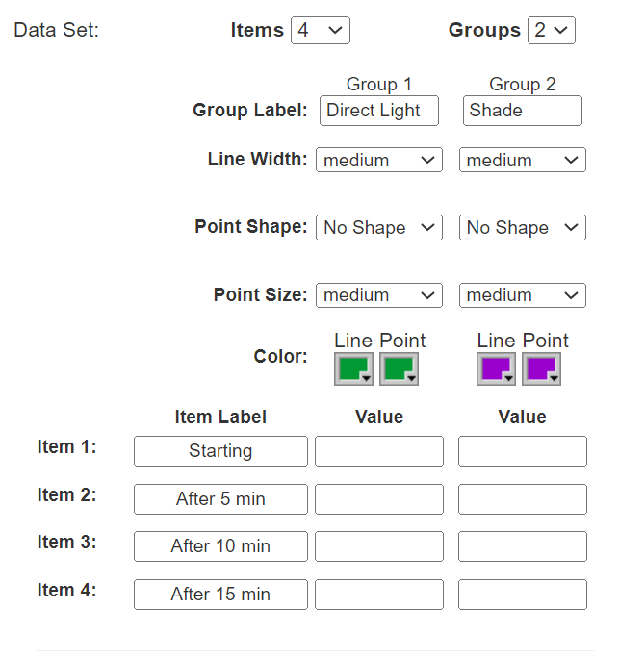

1. **Make sure to have no labels and include a legend**
2. **Paste graph below**

**C. Station Three- Part Two**

**Conclusion**

Answer the following using complete and detailed sentences. Use data to support your reasoning.

Explain how light affects a radiometer.Use data to support your reasoning.

What energy transformations occurred? Use data to support your reasoning.

| The light powers the radiometer and it starts spinning. The closer it gets the faster it spins. The farther it gets the lower it spins. During our experiment we saw that mechanical energy and heat energy were at work here. When the radiometer spins combined with the waves sent by the heat and the gear moving inside it, but the heat powers up the gears to make the thing work. So without the light or heat the thing doesn’t work. |
| --- |

**D. Station Three- Part Three: Solar Panel**

**Conclusion**

Answer the following using complete and detailed sentences. Use data to support your reasoning.

Explain how changing the angle of the solar panel affected electricity production.Use data to support your reasoning.

What energy transformations occurred? Use data to support your reasoning.

| When we changed the distances we saw if it was very close the fan would go very fast, but if not farther it would go slower. The angles were different but they all became either slower or faster which is one of the reasons mechanical and heat energy were the main energy source. |
| --- |

**E. Station Five- Part One: Glow Sticks**

**Conclusion**

Answer the following using complete and detailed sentences. Use data to support your reasoning.

Explain how temperature affected the rate of the chemical reaction in the glow stick. Use data to support your reasoning.

What energy transformations occurred? Use data to support your reasoning.

| The heat, chemical, and radiant energy combined with the cold water creates a dark radiant purple form of water. The heat when combined with a glow stick barely makes it brighter. The room temperature water is in the middle. Chemical energy combines with all the water but some are not really affected by it like the heated water while the cold water was affected by it. |
| --- |

**F. Station Six-Part Two: Hand Generated Flashlight and Motors**

**Conclusion**

Answer the following using complete and detailed sentences. Use data to support your reasoning.

Compare a hand generated flashlight and a motor. Describe the similarities and differences. Use data to support your reasoning.

What energy transformations occurred? Use data to support your reasoning.

| When I was pulling the handle the mechanics inside the flashlight made the gears move fast so an electrical pulse was created to create light the faster you pulled the handle. Mechanical energy was one of the energy sources because there were mechanics which mechanical energy is all about. Electrical energy was also at work because a pulse of energy transferred into the wires to use electricity to power up the flashlight. |
| --- |